**Suggested Reading:** Modern X-ray Spectroscopy: XAS and XES in the laboratory [1]

**Vocabulary Words:**

**SBCA:** Spherically Bent Crystal Analyzer (SBCA). A perfect crystal (often Si or Ge) that is first cut along a particular (hkl) lattice plane and then bent such that the Bragg angle changes continuously along the surface of the crystal.

**Source:** The origin of the isotropic emission. It may be fluorescence from an irradiated sample or radiation from an x-ray tube.

**Exercise:**  In each case in the diagram below there is a central angle θ and an inscribed angle 𝜙. Using a pair of safety scissors, cut out the θ angle at the bottom (below the 3 cases) and use it to visually confirm that the central angle is the same in each case. Then fold your cutout in half along the dashed line and visually confirm that the angle θ is equal to twice angle 𝜙 in each case.

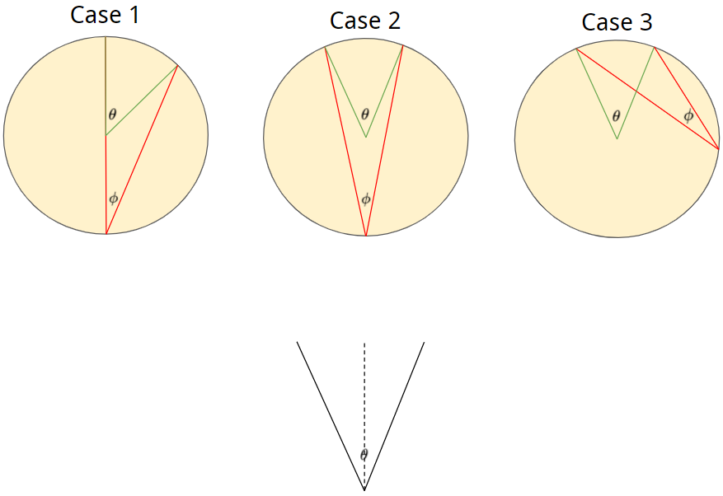

1. Rowland Circle
2. Mathematically show that 2ϕ = θ. This is known as the inscribed angle theorem. (Hint: Start by drawing a line connecting the green and red dots)

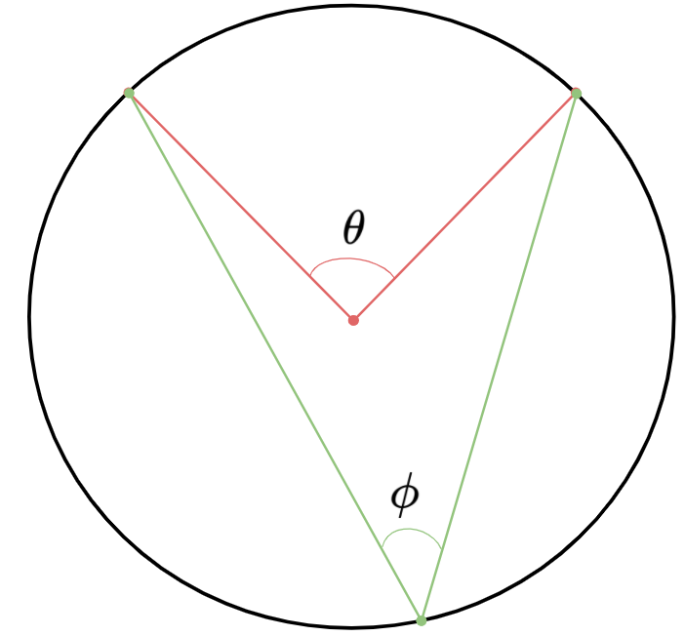

See ref [3], <https://www.khanacademy.org/math/geometry/hs-geo-circles/hs-geo-inscribed-angles/a/inscribed-and-central-angles-proof>, for a proof which addresses all cases of the inscribed angle theorem.

1. From the proof you completed in the previous problem it is clear that ϕ is the same for each of the inscribed angles below. Draw a bisecting line for each inscribed angle. Where do these lines intersect?

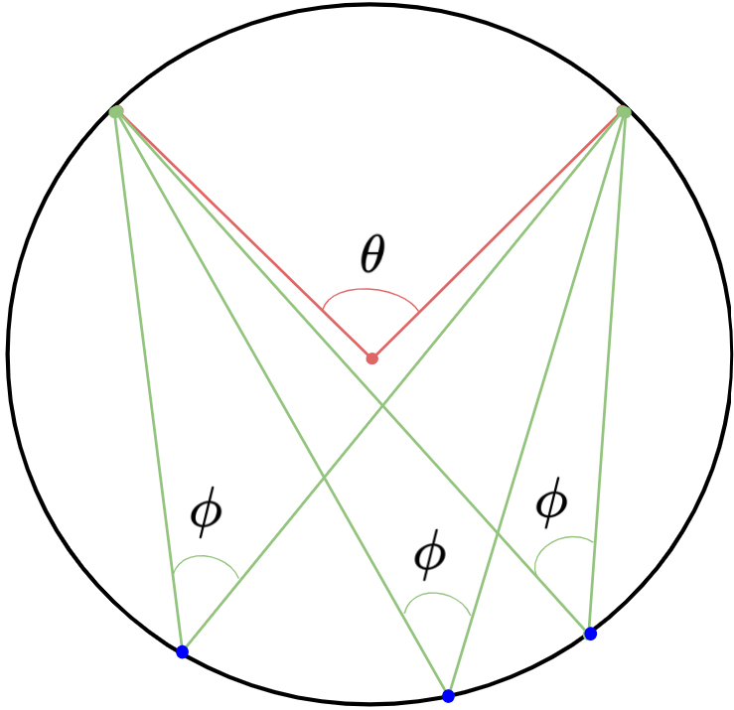

They intersect at the very bottom of the circle.

1. For any sufficiently small region, a circle can be approximated as a flat surface. Light reflects off of a surface at an angle equal to the angle of incidence as shown below.

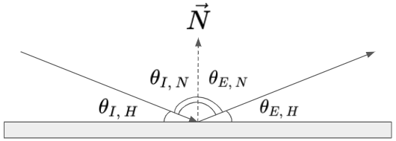

If the green lines shown in the previous diagram of the previous problem are light rays, do they reflect off of the interior of the circle in the way that we expect them to? If not, what circle do they *appear* to be reflecting off of? (Hint: Consider the convergence of the normal vectors from the previous problem)

No, they do not behave the way we would expect them to. They behave as if they were reflecting off a *different* circle with a center positioned at the apex (top) of the circle which is drawn. These reflections correspond to a circle which has twice the radius of the circle which is actually drawn.

1. Imagine that you wanted to bend a crystal such that you could achieve the consistent point to point reflection that the diagram in part B demonstrates. Below are three Rowland circle setups. The first has a crystal bent to a radius of R. The second has a crystal bent to a radius of 2R. The third has a crystal bent to a radius of 2R and the crystal has been ground down so that it lies along the Rowland circle at all points. For each of them draw the reflections of the light rays emitted from the point source, and don’t be afraid to break out your protractor! Which of them performs the best for point to point reflection?

The Johannson geometry beforms the best, but the Johann is a close second. For the crystal bent to just R, most of the reflected rays will be nowhere close to the detector. For the Johann geometry most of them get pretty close, but all except for the center beam is slightly off. For the Johannson geometry they all have perfect point to point reflection.

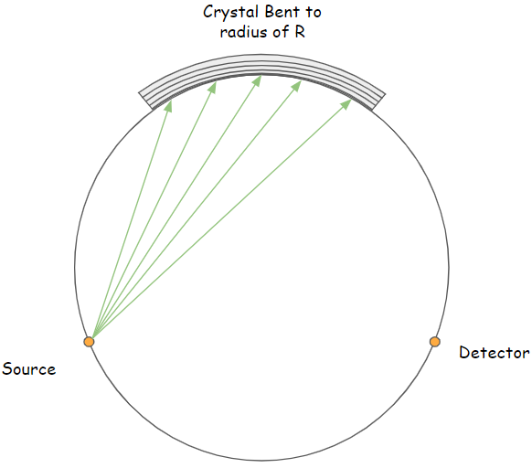

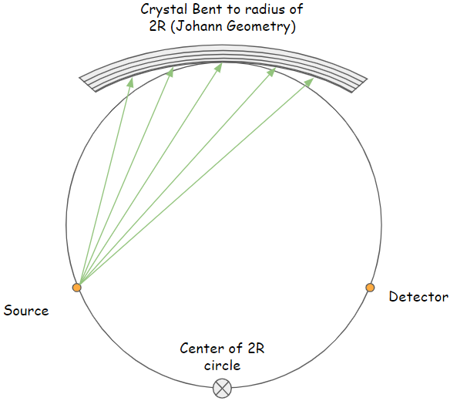

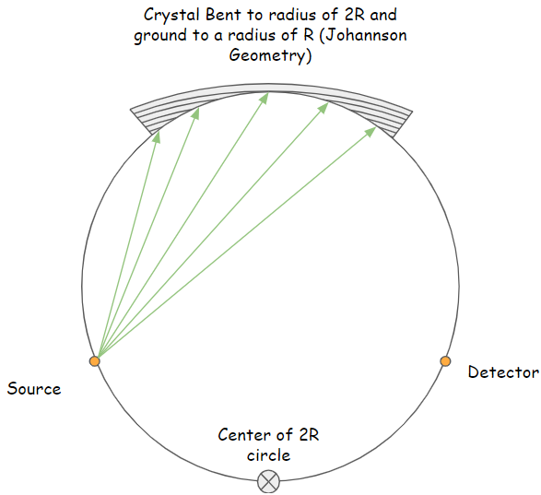

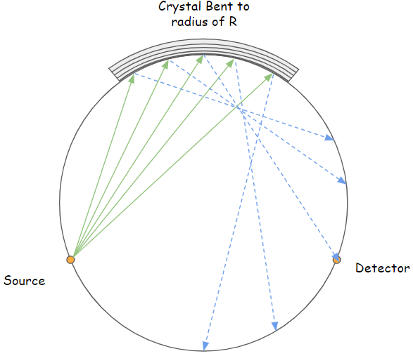

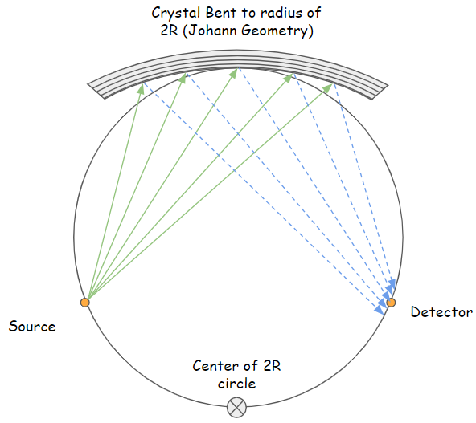

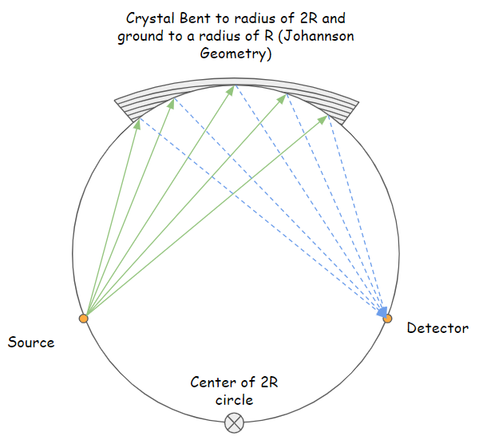

1. For real experiments an important consideration is that the crystal must be bent to a different radius of curvature than the Rowland circle. Therefore it can only touch the Rowland circle at a single point. To address this, the crystal surface can be first bent to the appropriate radius and then ground down so that it matches the curvature of the rowland circle as shown in the Johannson geometry diagram. However, this is a difficult and expensive process, so the Johann geometry is commonly used instead. This introduces what is known as the Johann error. Based on the previous problem, what can you conclude about the Johann error? Qualitatively how does it change depending on the distance of the incident ray from the apex (where the center ray hits in each of the diagrams)?

The Johann error becomes more pronounced the farther away the ray is from the apex of the Rowland circle.

1. The Rowland circle geometry is commonly described as having point to point focusing. What is meant by this?

This means that for a ray which is emitted from some point on the Rowland circle, it will always be reflected (in the ideal case) to the same corresponding point on the other side of the Rowland circle. This is distinguished from point to line focusing, which is commonly used to describe the Von Hamos geometry.

1. The Rowland circle geometry is highly versatile and is highly applicable in a number of x-ray spectroscopy settings. Answer the following questions about applications of the Rowland circle. Just give a brief response for each, you do not need to go into detail.
   1. What is X-ray raman scattering? How are Rowland circle optics used in it to collect non-resonant inelastic x-ray scattering data?

Non-resonant inelastic scattering (NRIXS) can probe very small excitations in a material by having the incident photon lose only a very small amount of energy. This allows us to probe photonic modes by having a very large Rowland circle (around 10 meters diameter). Effectively, the geometry of the Rowland circle allows us to have very high energy resolution, enough so as to detect excitations on the meV scale. Note that this does come at the cost of decreased count rates.

* 1. What is resonant inelastic x-ray scattering? How are Rowland circle optics used to collect data?

Resonant inelastic x-ray scattering (RIXS), otherwise known as resonant x-ray raman scattering, is a spectroscopy in which the energy of the incident x-rays is tuned to a specific edge energy (ex: 1s). The excited state then decays and the emitted photon energies are measured. The energy transferred to the system is compared against the incident energy, creating what is known as the RIXS plane. Rowland circle optics are used for precisely measuring the radiation from the decay of excited energy levels.

* 1. How can these optics be used for XES in a synchrotron or lab setting?

When studying XES the goal is to measure the intensity of emitted fluorescence photons with very resolving power, on the order of $\frac{E}{ΔE}≥5000$. Because of the point to point focussing of the Rowland circle, the fluorescence (of a specific energy) can all be collected onto a high resolution position sensitive detector, allowing one to clearly observe features within the XES spectra.

1. So far we have only considered the Rowland circle in 2 dimensions. However the fluorescence emitted from a sample is generally isotropic, or at least is emitted in 3 dimensions. Given this, explain why it is important to consider not just the crystal’s radius of curvature in the Rowland plane, but also the curvature in the direction perpendicular to the Rowland plane. See ref [4] for helpful visuals. This is what gives rise to sagittal error and the need for toroidally bent crystal analyzers.

When moving from the standard 2D picture of a Rowland circle to an actual setup in 3D space. The solid angle which the experiment is sensitive to now depends on how the crystal analyzer is bent in multiple dimensions.

Picture the Rowland circle as lying in the horizontal plane. In 3D, real sources will not emit rays only in the plane of the Rowland circle. Some radiation will fly slightly above or below the plane. From the detector’s point of view, the beam must be focused in both the horizontal and vertical directions. To achieve this focusing in two dimensions, the analyzer must not only be bent to 2R in the Rowland plane, but also bent perpendicular to the plane such that rays converge on the detector. If the beam focus is at different points in the sagittal and meridional (vertical and horizontal) plane it will cause error.

1. Assuming you’ve established a working crystal analyzer in 3D, explain how one could use multiple identical Rowland circles to increase the accessible solid angle.

Consider the Rowland circle as it is presented in the diagrams of problem E. Imagine that a rod is passed through the source and detector. The entire setup is then rotated about that rod, pushing the bent crystal out of the plane of the page. If we label the rod passing through the source and detector as the z axis, then the rotation of the setup traces out a circle in the polar direction. By placing additional toroidally bent crystals periodically along this circle, we can create multiple identical Rowland circles, with each one increasing the solid angle available to the detector. This design is explained in more detail (with excellent figures) in reference [2].

1. Why is accessible solid angle a concern for experiments which employ this geometry?

More signal, experiment goes faster.

1. Von Hamos
2. Consider the diagram shown below. Assume the source emits photons over a continuous range of energies, and that the monochromator is a perfect single crystal. Using the colors red, green, and blue (red being lowest energy, blue being highest energy) draw how the radiation emitted from the source will reflect off the monochromator, and where it will land on the detector. (Hint: Remember that constructive interference only occurs when the path length is equal to an integer number of wavelengths. Therefore, you should not have any “red” energy photons reflecting at the same angle as “blue” energy photons (or any other “color” energy other than red).

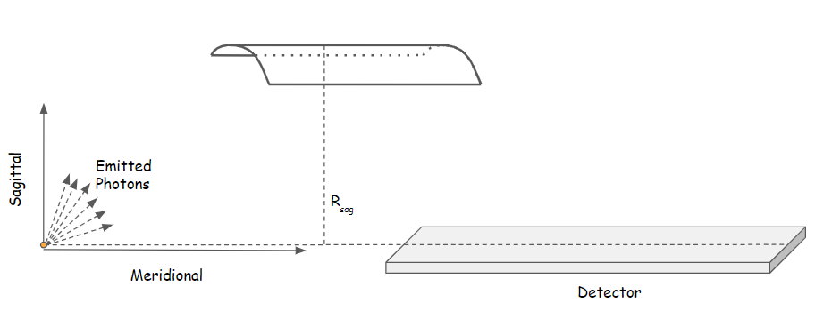

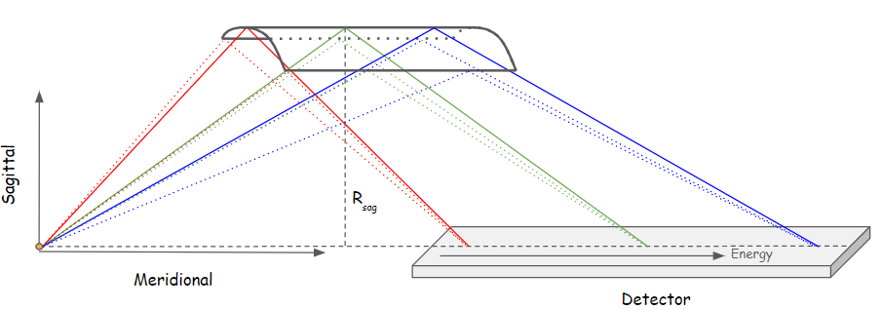

1. As mentioned earlier, the Rowland Circle geometry is described as point to point focusing. With this in mind, what kind of focusing does the Von Hamos geometry exhibit? Explain.

The Von Hamos instrument exhibits point to line focusing. The radiation emitted from the point source gets reflected onto a line where the distance along the line corresponds to the energy (wavelength) of the reflected light.

1. As with the Rowland Circle geometry, it is advantageous to increase the accessible solid angle. How could this be easily achieved in the Von Hamos geometry?

Multiple bent crystals (of the same radius of curvature) can be arranged radially around the meridional line so as to create a circle to “capture” more of the fluorescence radiation coming off the sample. Additionally, even more of these experimental setups could be added in the meridional plane of the detector, spaced at a constant distance away from the source.

1. What is the trade off between Von Hamos and Rowland, at least in the synchrotron setting?

In the context of synchrotrons, Von Hamos has a higher solid angle, more convenient, but lower energy resolution and the fact that it is point to line requires more shielding. Rowland requires less shielding and can be more difficult to set up and operate, but has higher energy resolution.

Citations:

[1] Zimmermann, Patric, et al. “Modern X-Ray Spectroscopy: XAS and XES in the Laboratory.” *Coordination Chemistry Reviews*, vol. 423, 2020, p. 213466., doi:10.1016/j.ccr.2020.213466.

[2] Sokaras, D., et al. “A Seven-Crystal Johann-Type Hard x-Ray Spectrometer at the Stanford Synchrotron Radiation Lightsource.” *Review of Scientific Instruments*, vol. 84, no. 5, 2013, p. 053102., doi:10.1063/1.4803669.

[3] “Inscribed Angle Theorem Proof (Article).” *Khan Academy*, Khan Academy, [www.khanacademy.org/math/geometry/hs-geo-circles/hs-geo-inscribed-angles/a/inscribed-and-central-angles-proof](http://www.khanacademy.org/math/geometry/hs-geo-circles/hs-geo-inscribed-angles/a/inscribed-and-central-angles-proof).

[4] Missalla, T., et al. “Monochromatic Focusing of Subpicosecond x-Ray Pulses in the KeV Range.” *Review of Scientific Instruments*, vol. 70, no. 2, 1999, pp. 1288–1299., doi:10.1063/1.1149587.